Rube Goldberg Machine F15
Assembly & Operation Manual

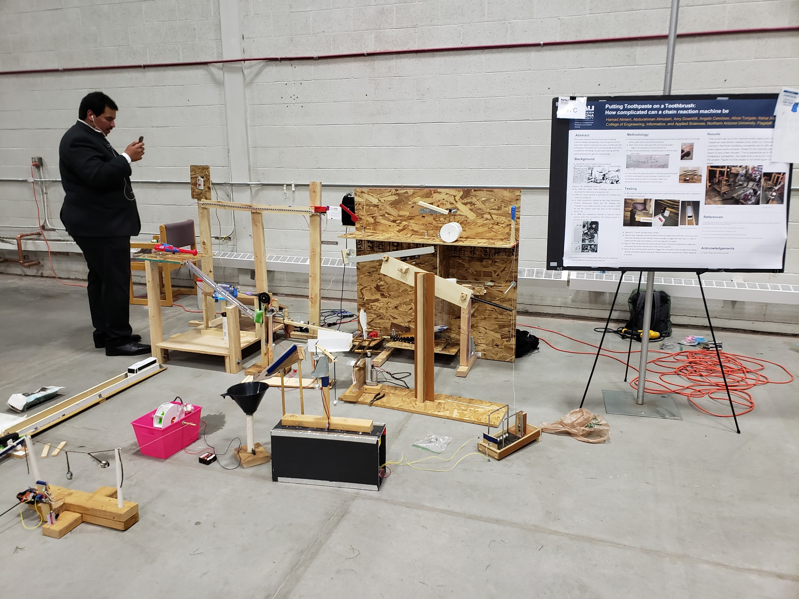
Created by:
Angelo Cencioso, Amy Downhill, Alivia Tongate, Abdulrahman Almutairi, Hamad Almerri, Nahar Alotaibi

Table of Contents
Table of Contents 1
Machine Assembly 2
Arduino Assembly 18
Steps 1-3 (button-light-servo) 18
Step 4 (inside mailbox) 20
Step 5 (outside mailbox) 21
Steps 12-13 (sensor-wiffle servo) 22
Machine Operation 23
Starting the Machine 23
Troubleshooting 24
How to Reset 26

Machine Assembly
Step 1: Collect the two 2’’x4’’ wood supports, two wood foot pieces, four small L-brackets, and 16 wood screws. Position two L-brackets between one of the 2’’x4’’ supports and foot pieces as shown in figures 1 and 2, and fasten them into place using the wood screws. Repeat for the other support and foot pieces.

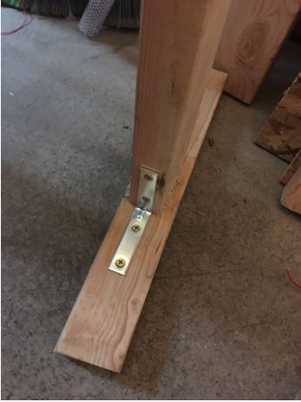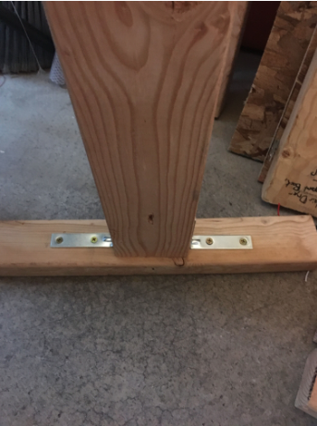
Figure 1: L-brackets View 1 Figure 2: L-brackets View 2

Step 2: Collect the LED light strip connecting plank and four wood screws. Use two wood screws to connect the connecting plank to each of the supports constructed in step 1 in the position shown in figures 3 and 4.
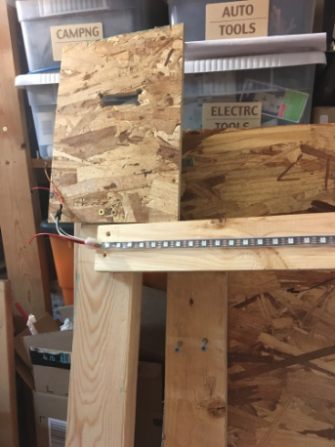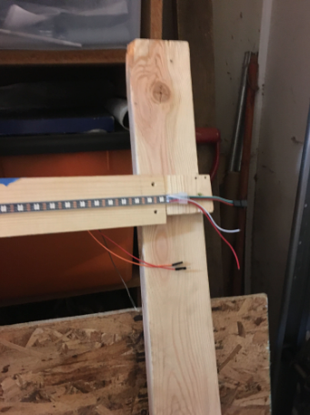
Figure 3: Left Hand LED View Figure 4: Right Hand LED View

Step 3: Collect the hairdryer-cart assembly, two small wood support pieces, and three long screws. Position back wood supports on the back side of the hair-dryer cart assembly, as shown in figures 5 and 6. Affix the supports to the assembly using long screws.

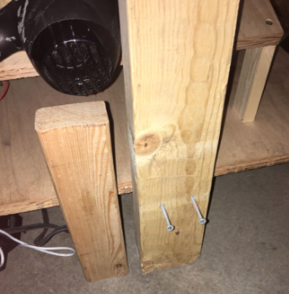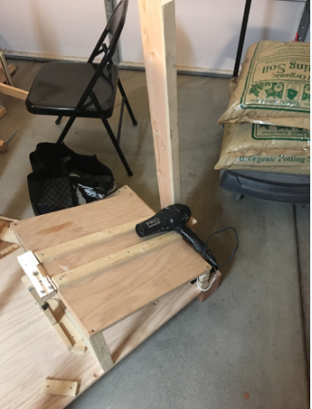
Figure 5: Wood Support View 1 Figure 6: Wood Support View 2

Step 4: Collect two long screws. Position the structure from steps 1 and 2 behind the hairdryer-cart assembly, and line up the screw holes between the small wood support piece and the LED light strip connecting stip, as shown in figure 7. Attach pieces together using long screws.

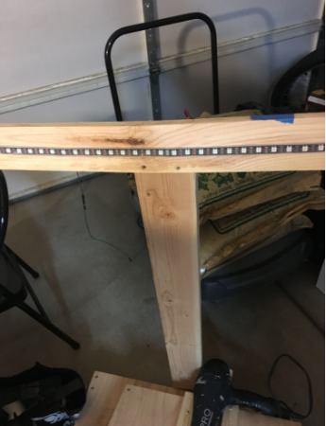
Figure 7: Middle Support View

Step 5: Collect the mail arm/continuous rotation servo motor component and two wood screws. Position the mail arm component on the LED light strip connecting plank as shown in figure 8. Affix the mail arm component using wood screws.

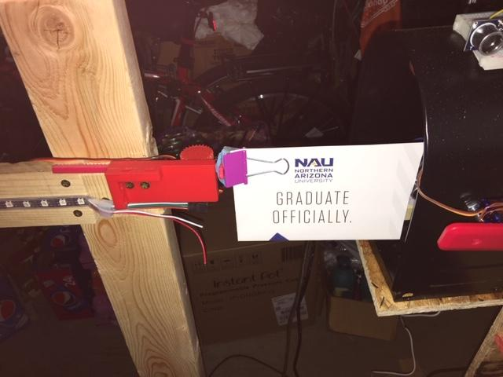
Figure 8: Mail Arm Position

Step 6: Collect the two OSB support pieces, 10 small screws, and corresponding washers and nuts for each screw. Nest the two OSB support pieces, lining up the holes on the connecting brackets as shown in figures 9 and 10. Send screws through the top of each connecting bracket, and secure them from the back using the nuts and washers.

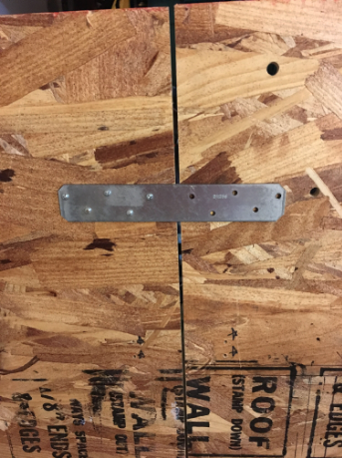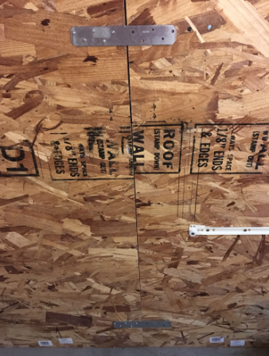
Figure 9: Connected OSB Board View 1 Figure 10:Connected OSB Board View 2

Step 7: Collect the three regular L-bracketed foot pieces, the L-bracketed foot piece with drawer attachment, and twelve medium screws. Position each of the four foot pieces on the OSB support structure. Each foot piece is numbered, and each will be positioned at its corresponding number on the OSB support as shown in figures 11 and 12. Attach each foot piece to the OSB support using the medium screws.

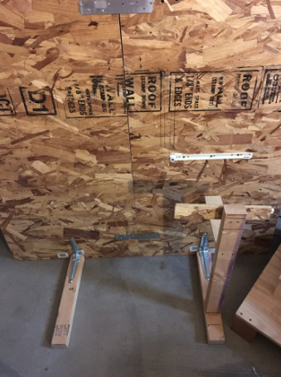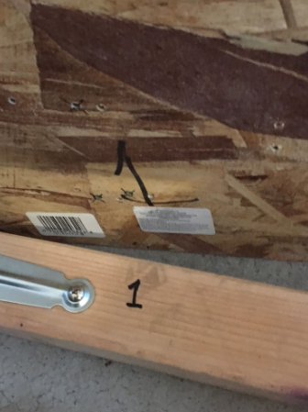
Figure 11: Foot Supports Figure 12: Screw Locations

Step 8: Collect the large OSB shelf component and eight wood screws. Position the large OSB shelf component on the front of the OSB support structure shown in figures 13 and 14. Attach the shelf component using wood screws.

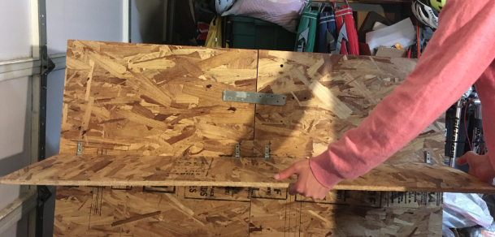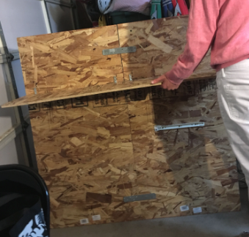
Figure 13: Large Shelf Component View 1 Figure 14: Large Shelf Component View 2

Step 9: Collect the medium OSB shelf component and eight wood screws. Position the medium OSB shelf component on the back of the OSB support structure shown in figure 15. Attach the shelf component using wood screws.

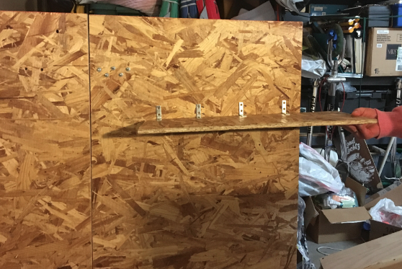
Figure 15: Back Shelf View

Step 10: Collect the double paneled OSB shelf, bellow, two long screws and six wood screws. Position the bellow on the top panel of the OSB shelf, lining up the holes on the bottom arm of the bellow with the holes on the shelf. Send the two long screws through these holes to attach the bellow to the shelf. After, position the shelf on the front of OSB support structure as shown in figure 16, and attach the shelf using the wood screws.

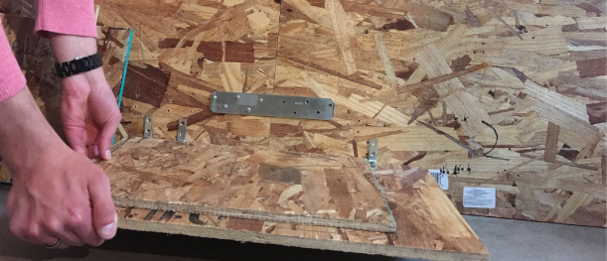
Figure 16: Double Panel Shelf View

Step 11: Collect the small OSB shelf, and four wood screws. Position the shelf of the front of the OSB structure as shown in figure 17. Use the wood screws to attach the shelf.

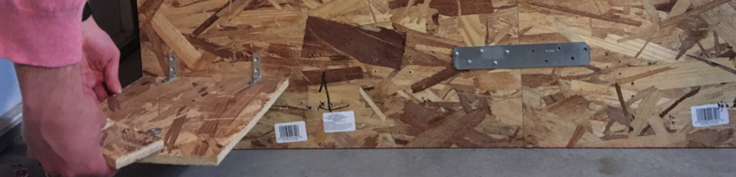
Figure 17: Small OSB Shelf View

Step 12: Collect the OSB shield piece and three wood screws. Position the shield piece on the front of the OSB structure as shown in figure 18. Attach the shield by sending screws through the back of the OSB structure into the shield.

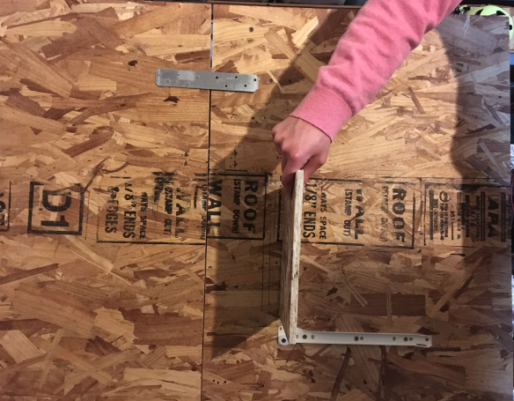
Figure 18: Shield Piece View

Step 13: Collect the large diameter clear tube and large zip tie. Position the clear tube above the bellow as shown in figure 19. Send the large zip tie through both holes on the clear tube and OSB support structure to keep it in place.

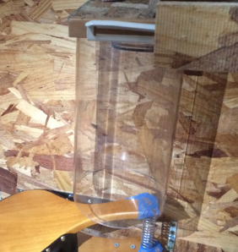
Figure 19: Clear Tube Position

Step 14: Collect the continuous rotation servo, bailing wire, wooden swing attachment, two ¼’’ threaded rods and corresponding nuts and washers. Send the threaded rods halfway through the two holes located at the top of the OSB support structure. Use the two nuts and two washers for each threaded rod to keep them in position. After, place the continuous rotation motor on the top of the threaded rods, positioned so that the white rotation gear extends past the front edge of the rods. Wrap bailing wire around the motor and threaded rods to keep it in place. Finally, snap the wooden swing attachment onto white rotation gear of the continuous rotation servo using the black plastic piece on the swing attachment. This is shown in figure 20.

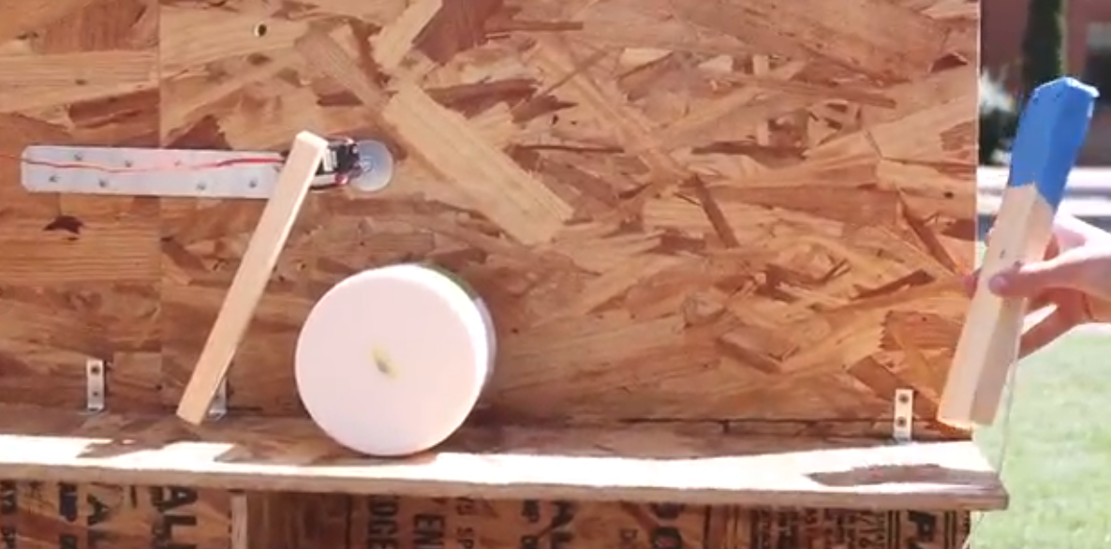
Figure 20: Continuous Rotation Servo with Attachment
Step 15: Collect the drawer slide and tethered weight. Place the drawer slide between the metal rails located on the OSB support structure and foot attachment, as shown in figure 21. After, place the tethered weight on the far right edge of the large OSB shelf.

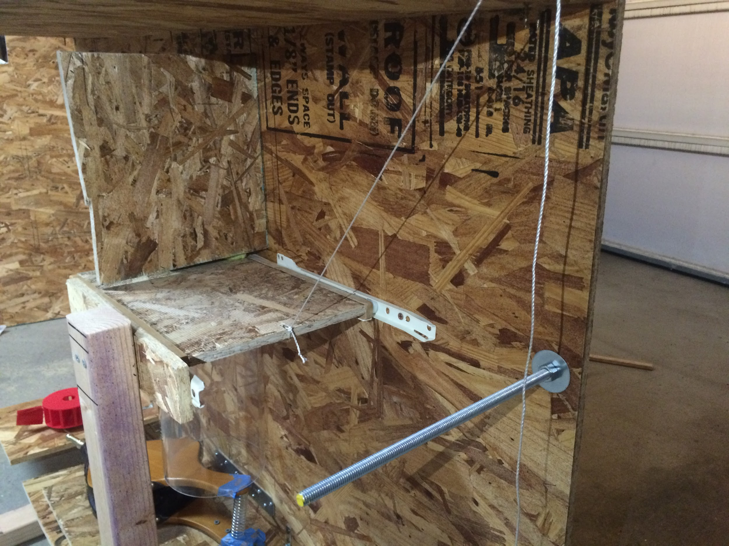
Figure 21: Drawer Slide in Rails

Step 16: Collect the river rock, rolling jar, spinner and large ball bearing. Position the river rock on the top of the drawer slide to the left of the shield piece, as shown in figure 22. Place the rolling jar just to the right of the swing attachment placed on the continuous rotation servo on top of the large OSB shelf, as shown in figure 20. Place the large ball bearing on the washer located on the small OSB shelf. Place the spinner in between the bearing and the nozzle of the bellow so that the arm of the spinner will contact with the bearing after rotation. This is shown in figure 23.

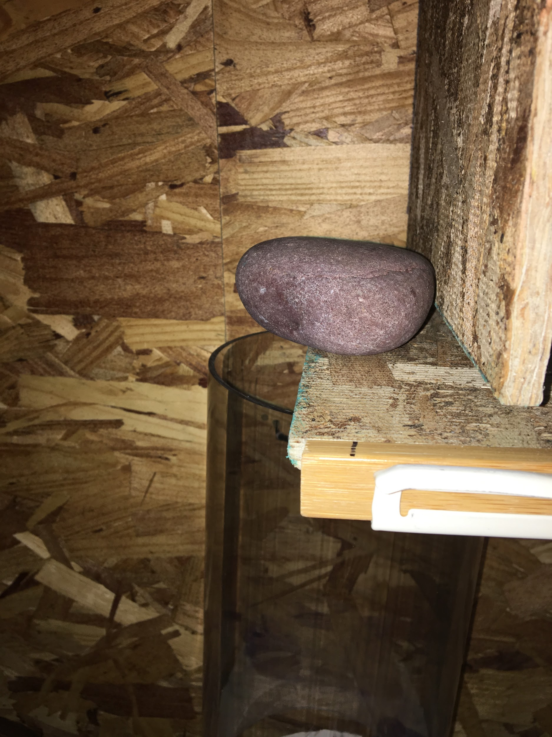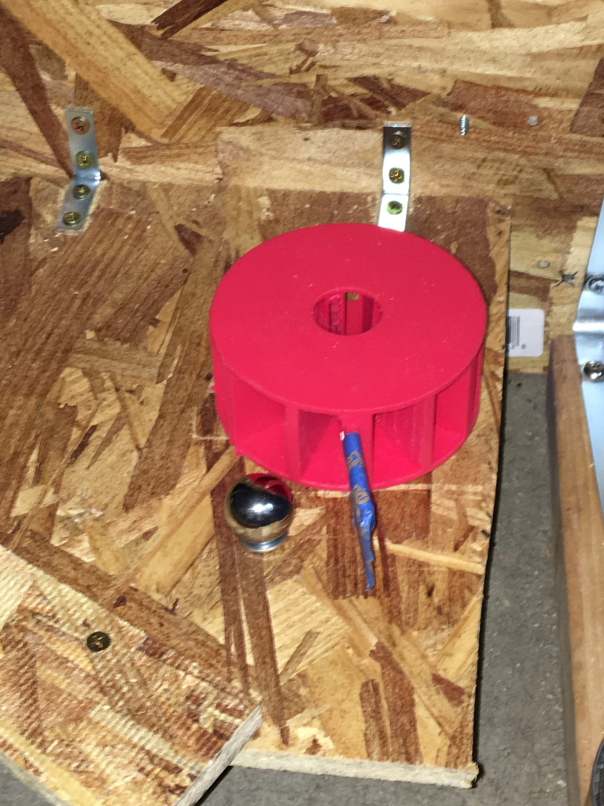
Figure 22: Rock Weight on Drawer Figure 23: Spinner and Ball Bearing

Step 17: Collect the lever arm component, cardboard catch basin, large zip tie, and corresponding washers and nuts. First, position the lever arm under the ramp portion of the hairdryer-cart assembly so that the bolt component falls under the button located on the attached breadboard, as shown in figure 24. Next, send the threaded rod through the hole on the bottom of the leg support for the LED light strip, and use the nuts and washers to keep it in place. Slide the cardboard catch basin onto the other end of the lever arm component, with the box facing out. Finally, place the zip tie around the lever arm and back right leg of the ramp of the hairdryer cart to keep it from moving laterally, as shown in figure 25.

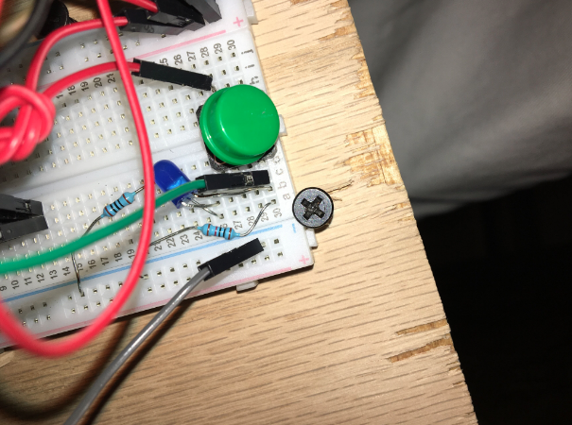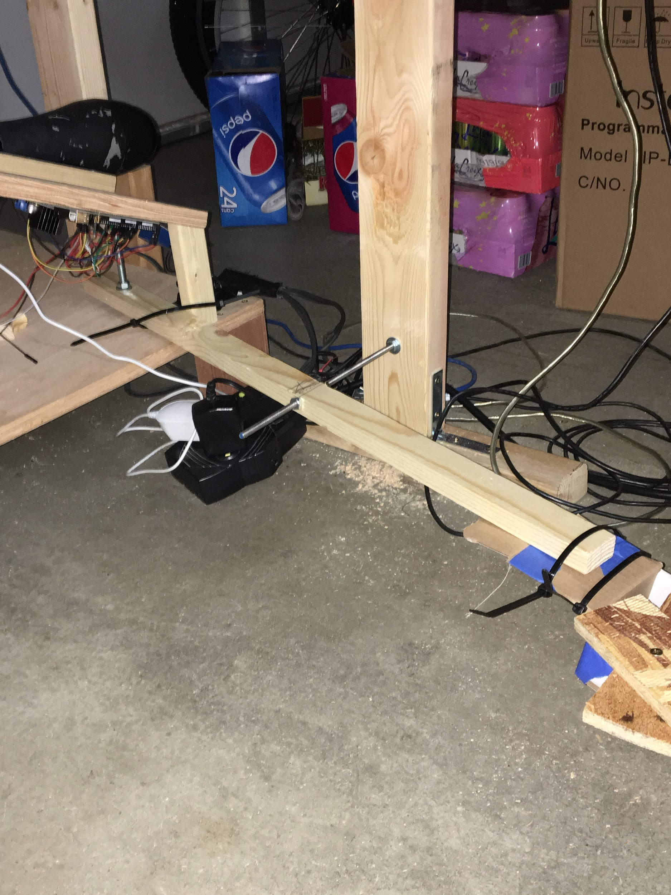
Figure 24: Button on Breadboard Figure 25: Lever Arm, Zip Tie-downs

Step 18: Collect the wooden bat swing support, four long screws, ½’’ threaded rod and corresponding washers and nuts. Position the leg of the wooden support on the front, left hand side of the hairdryer-cart assembly, as shown in figures 26 and 27. Use threaded rod and screws to keep component in position.

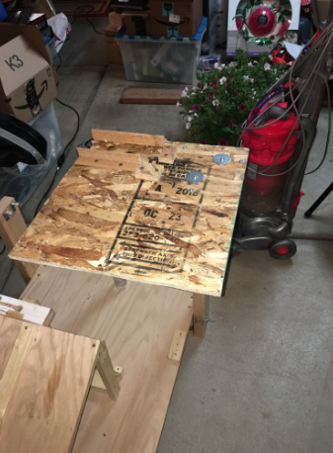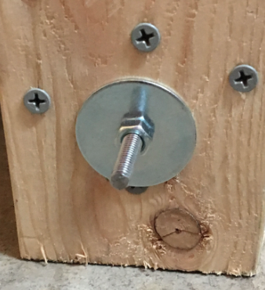
Figure 26: Bat Swing Support Figure 27: Threaded Rod and Screw Fasteners

Step 19: Collect clear tube wood support, four long screws, ½’’ threaded rod and corresponding washers and nuts. Position wood support on the front, right hand side of the hairdryer-cart assembly across from the wooden bat swing support, shown in figures 28 and 29. Use threaded rod and screws to keep component in position.

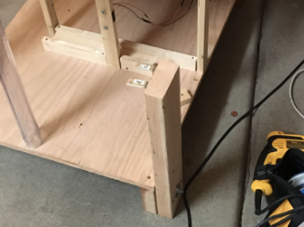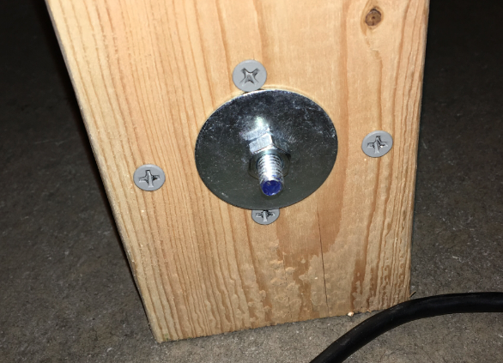
Figure 28: Clear Tube Support Figure 29: Threaded Rod and Screw Fasteners

Step 20: Collect small diameter clear tube and two small zip ties. Place the clear tube on top of the wood support and nest the end of the tube with the small holes between the slot on the wooden bat support, as shown in figure 30. Send zip ties through holes in tube and holes in the top component of the wooden bat support to keep the tube in place.

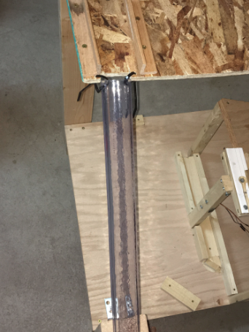
Figure 30: Clear Tube, Zip Tie Attachment

Step 22: Collect the plastic bat attachment and small ball bearing. Snap the plastic bat attachment into the white rotation gear of the servo motor on the bat swing support using the black plastic snap on the bat. Place the ball bearing on the nuts located on the top of the bat swing support. This is shown in figure 31.

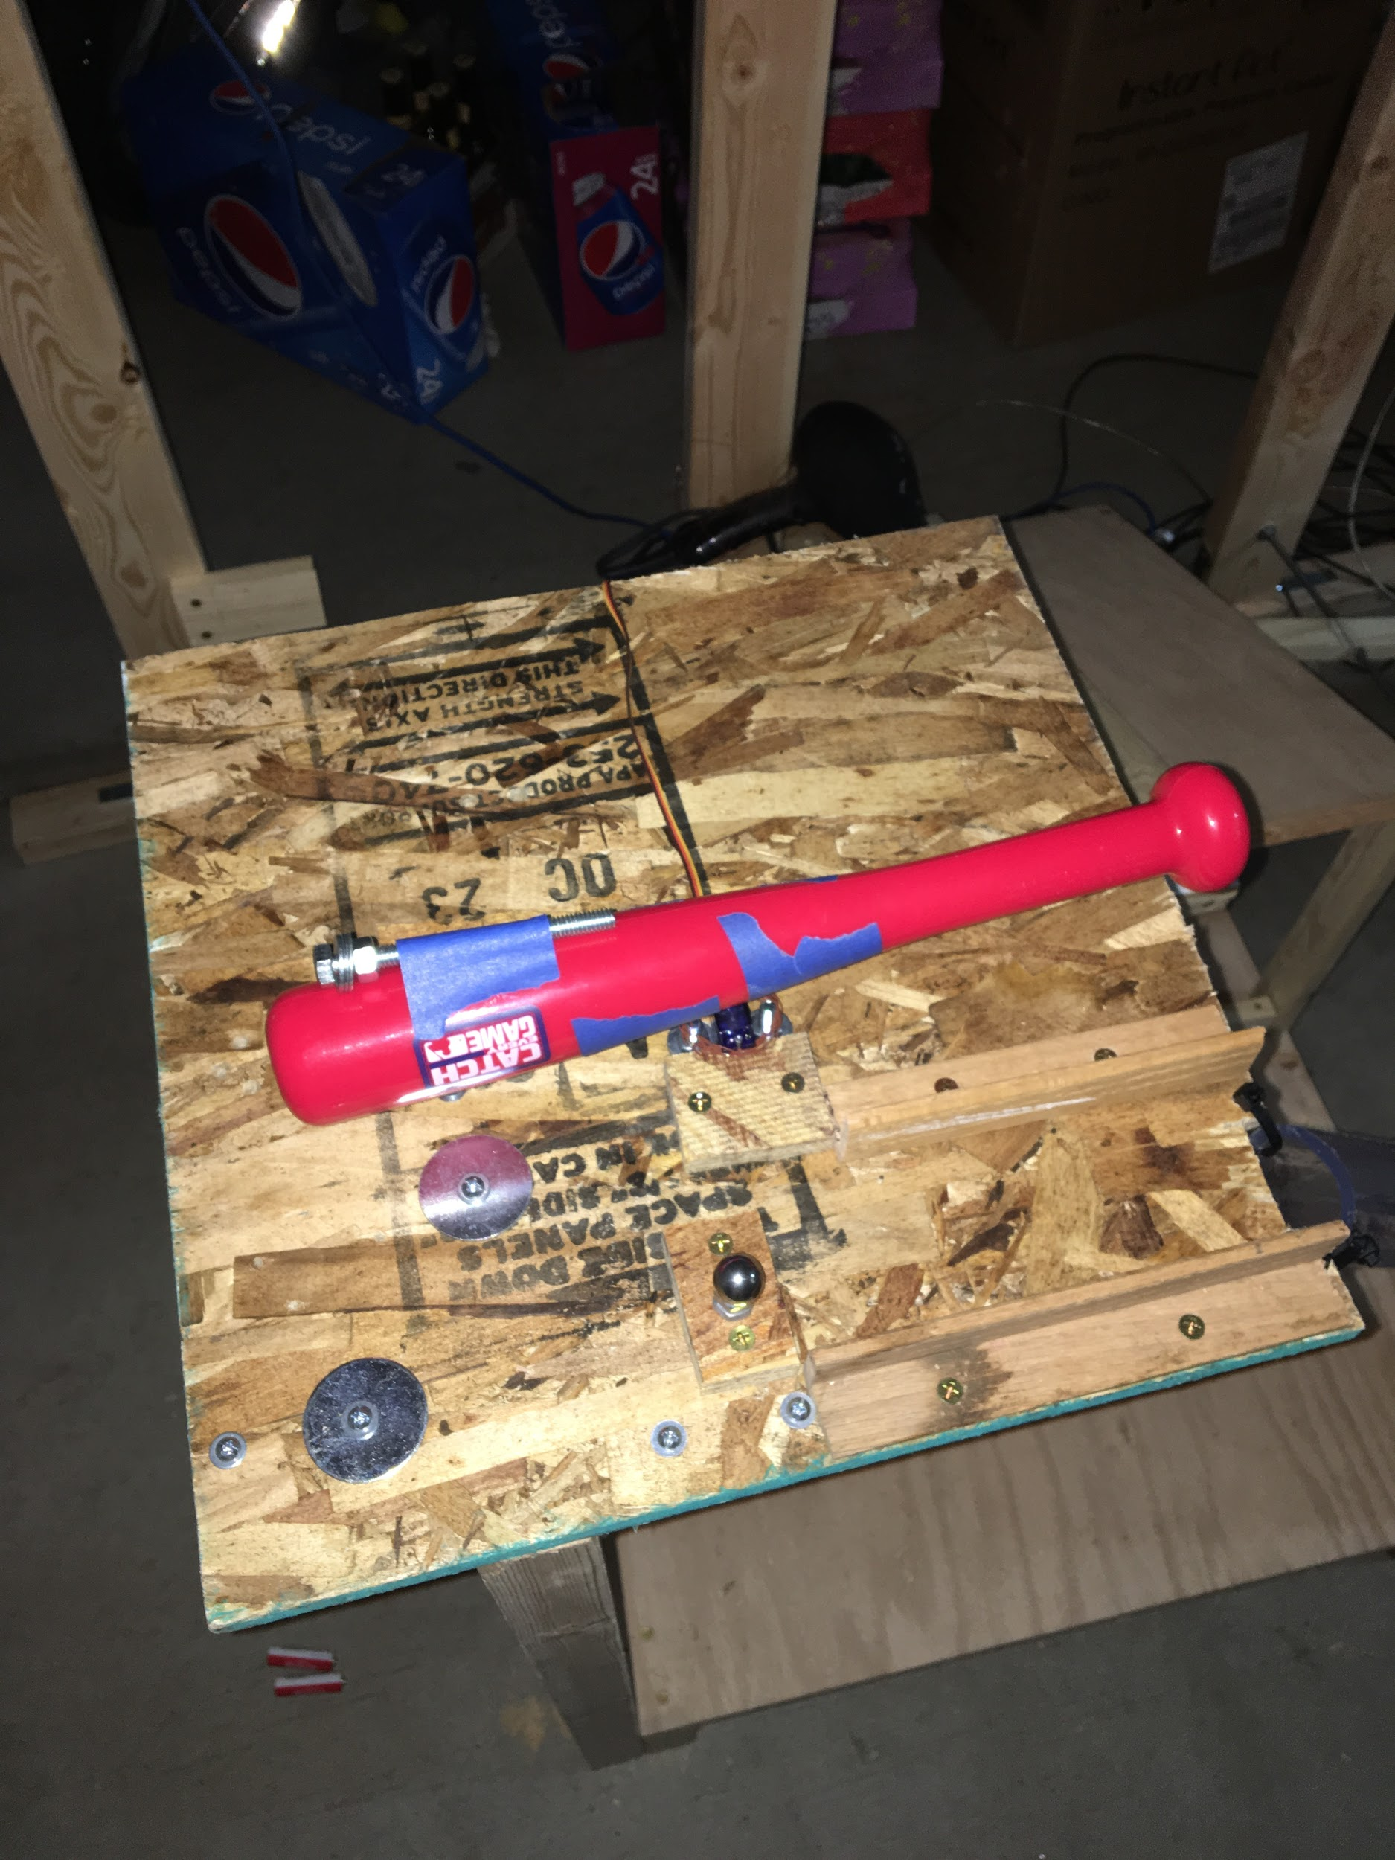
Figure 31: Plastic Bat Attachment and Ball Bearing

Step 22: Collect the mailbox component. Position the mailbox with the opening facing to the left and the mail flag facing forward on the medium OSB shelf as shown in figures 32 and 3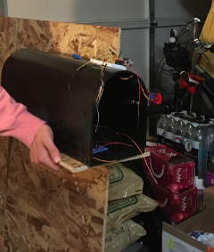 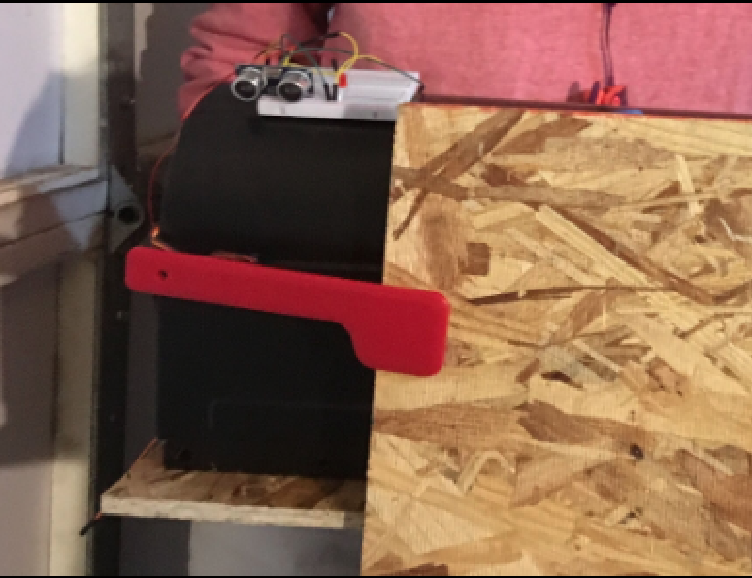 Figure 32: Back View of Mailbox Figure 33: Front View of Mailbox

Step 23: Collect the toy car, the mass pulley step and the toy car drop steps. Position the box entry of the mass pulley step at the bottom exit of the small clear tube as shown in figure 34. Place the toy car drop to the right of the mass pulley step, facing the narrow end of the car drop to the right. Place the toy car on the top ramp of the drop step, as shown in figure 35.

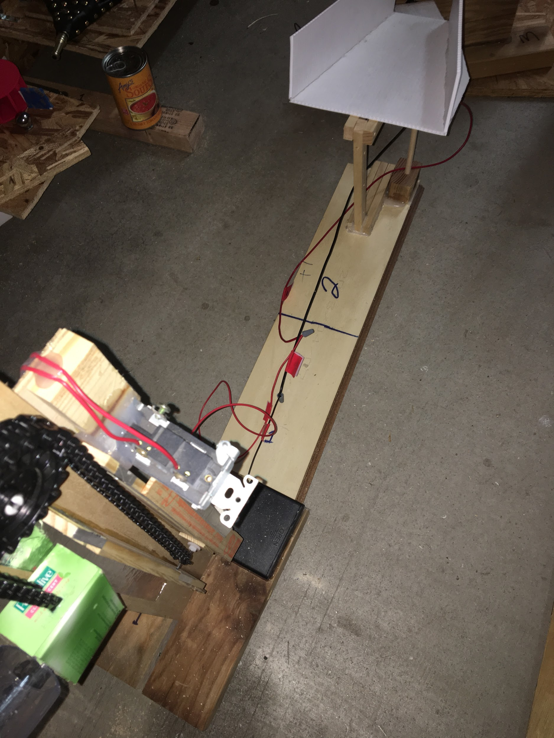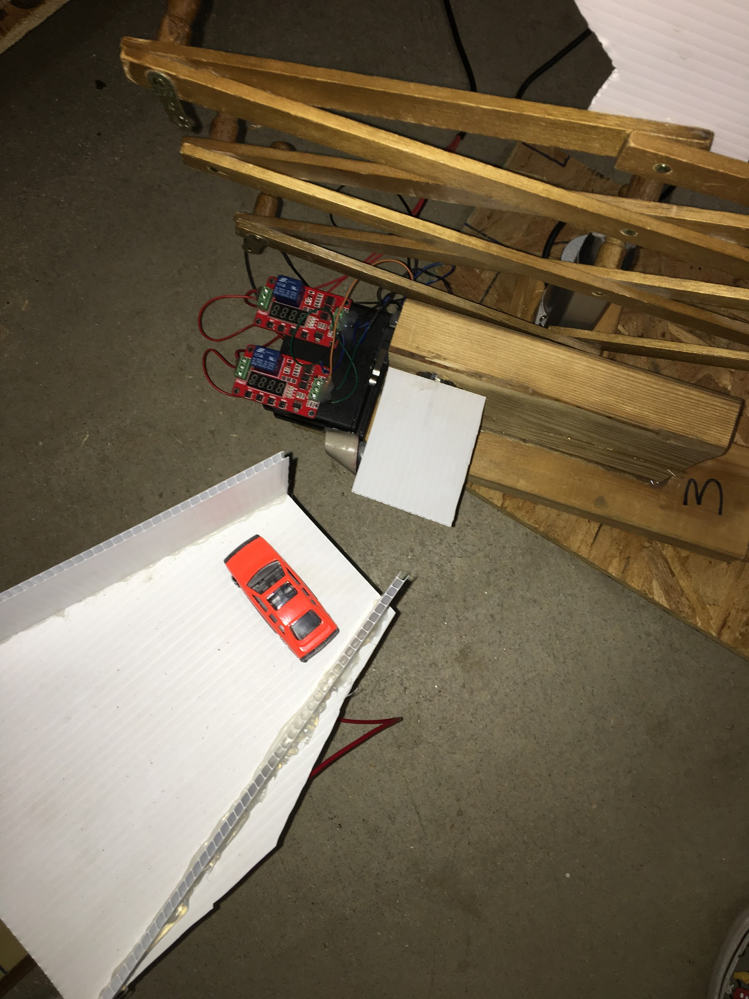
Figure 34: Mass Pulley Placement Figure 35: Toy Car Drop Placement

Step 24: Collect the plastic ball, scissor lift step, and plastic ball ramp. Position the trigger arm of the scissor lift step directly under the narrow end of the car drop, so that the toy car can trigger the step. Next, position the metal portion of the ball ramp directly over the punching arm, so that the lift can move that end of the ramp. Finally, place the plastic ball on that same end. This is shown in figure 36.

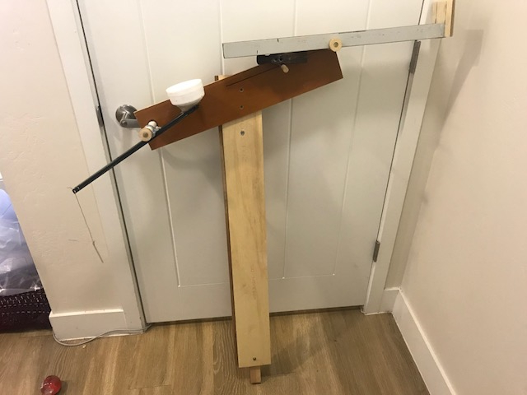
Figure 36: Plastic Ball Ramp

Step 25: Collect the Newton’s cradle step and the centripetal force step. Position the Newton’s cradle step under the cup swing portion of the plastic ball ramp step. Connect the separating wire of the Newton’s cradle step to the cup swing to separate the first ball in the cradle, which will allow it to swing into the rest of the cradle to then trigger the switch for the centripetal force step. Position the newton’s cradle step to the left of the cradle. This is shown in figures 37 and 38.

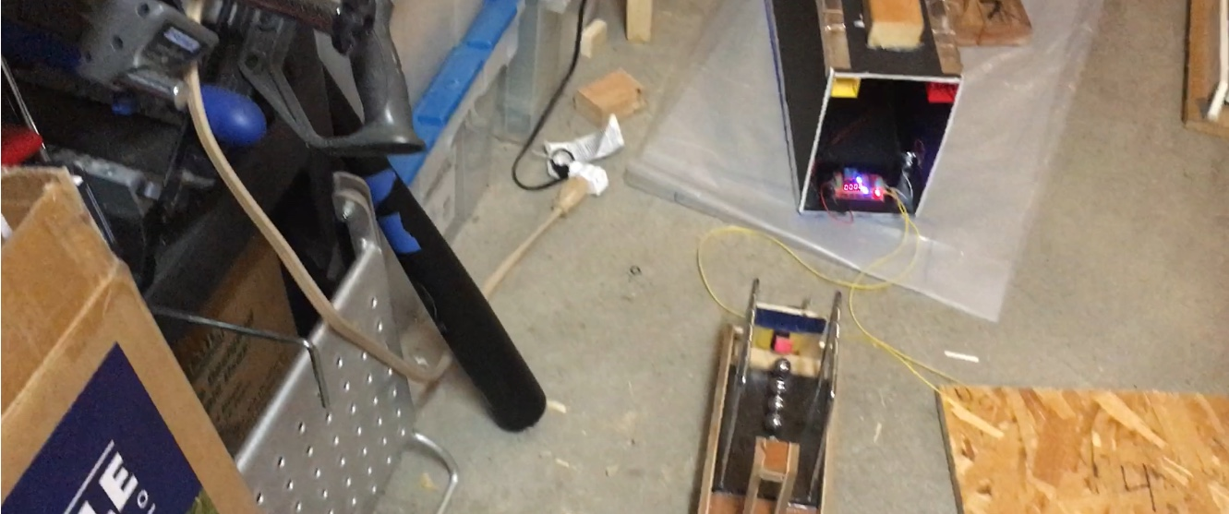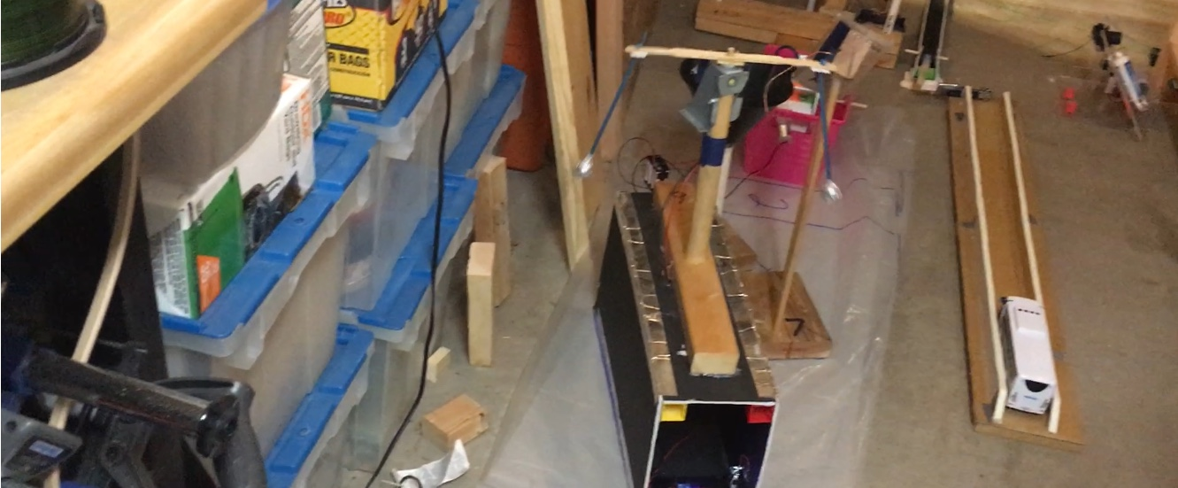
Figure 37: Newton’s Cradle Placement Figure 38: Centripetal Force Placement

Step 26: Collect the coin ramp, metal wire, quarter, coin funnel step, and water wheel step. Position the coin ramp right next to the centripetal force step. Place the metal wire through the top end of the ramp, which will keep the coin from rolling down the ramp. After, place the quarter into the ramp slot. Next, place the coin funnel right at the bottom of the coin ramp so that the coin will enter the funnel and spin. Finally, place the water wheel to the left of the coin funnel. The assembly is shown in figures 38 and 39.

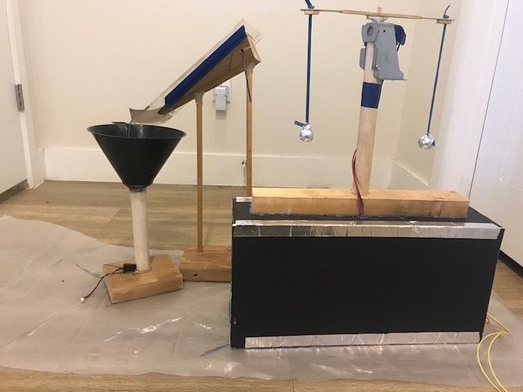
Figure 39: Coin Funnel and Ramp Assembly

Step 27: Collect the dual pendulum step. Using the magnetic tether attached to the water wheel step, attach the tether to the pendulum that is free from the switch. When the water wheel step functions, it will coil up the tether, which will pull the magnet off of the pendulum, which starts its motion. This motion transfers to the other pendulum, that then contacts with the switch. This is shown in figure 40.

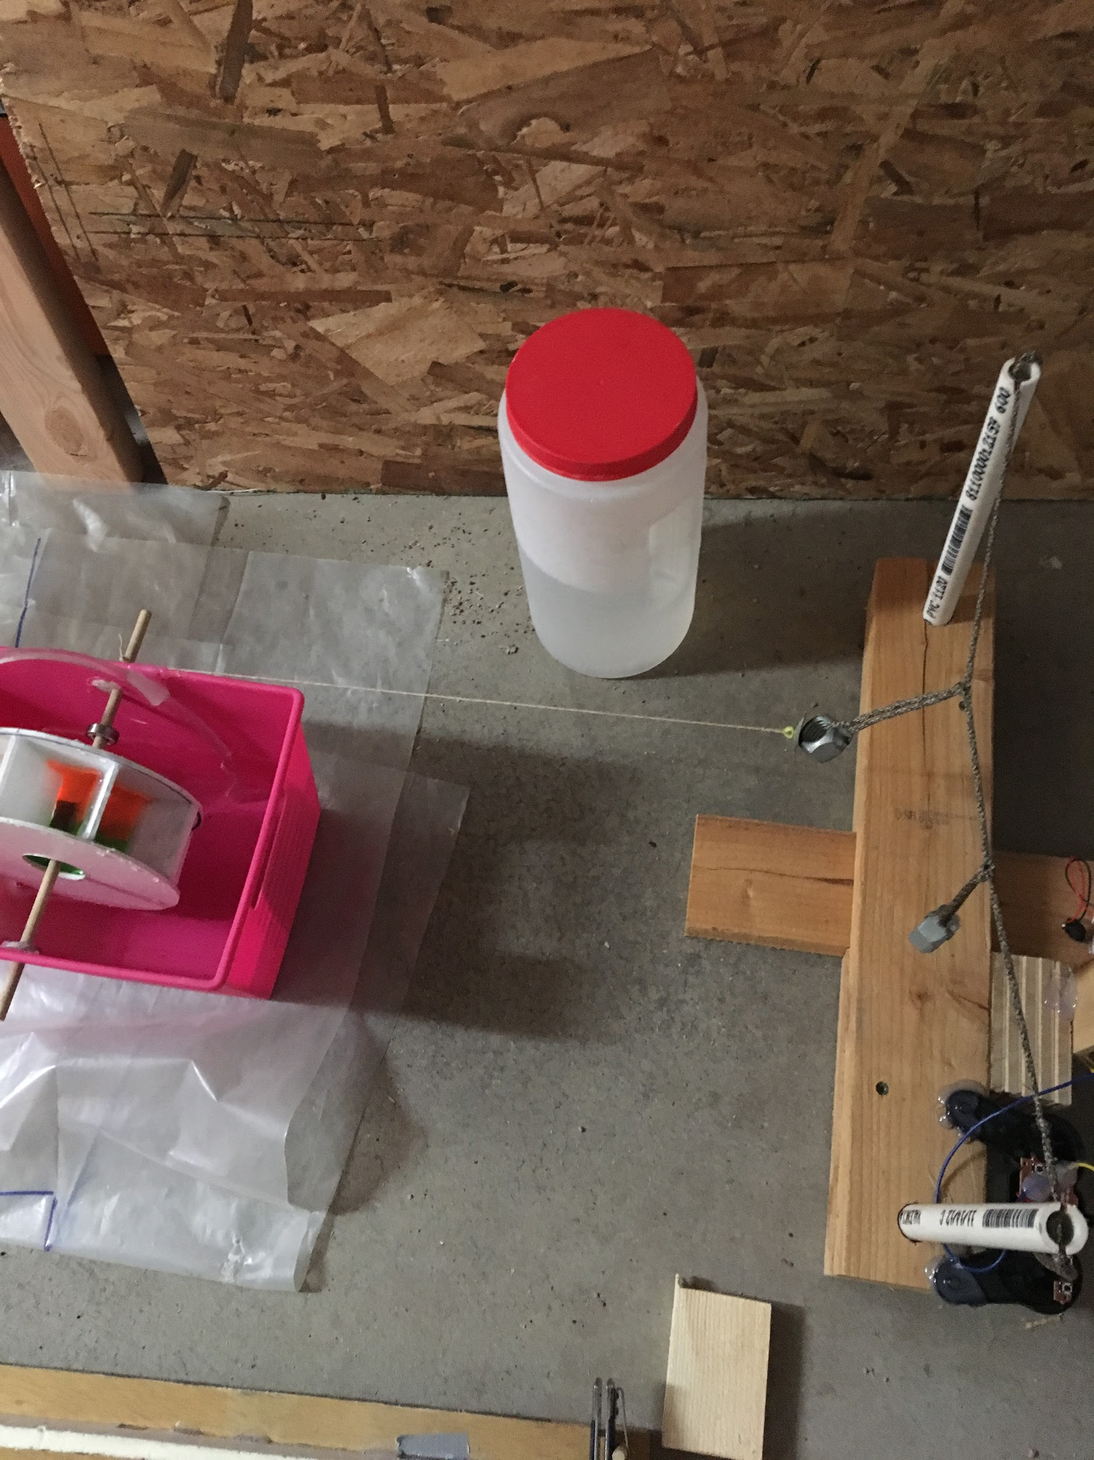
Figure 40: Water Wheel, Dual Pendulum, and Tether

Step 28: Collect the bus ramp, remote controlled bus, medium ball bearing, ball canon ramp and toothpaste dispenser. Place the entrance of the bus ramp in between the mass pulley and coin funnel steps, and the exit next to the dual pendulum step. Place the remote controlled bus at the entrance of the track. Place the drop of the ball canon ramp just over the head of the toothbrush, so it will be triggered when the toothbrush opens. Place the ball bearing in the canon. Finally, position the toothpaste dispenser on the side of the ramp where the toothbrush is open, so that the toothpaste will land on the head of the toothbrush. This is shown in figure 41.

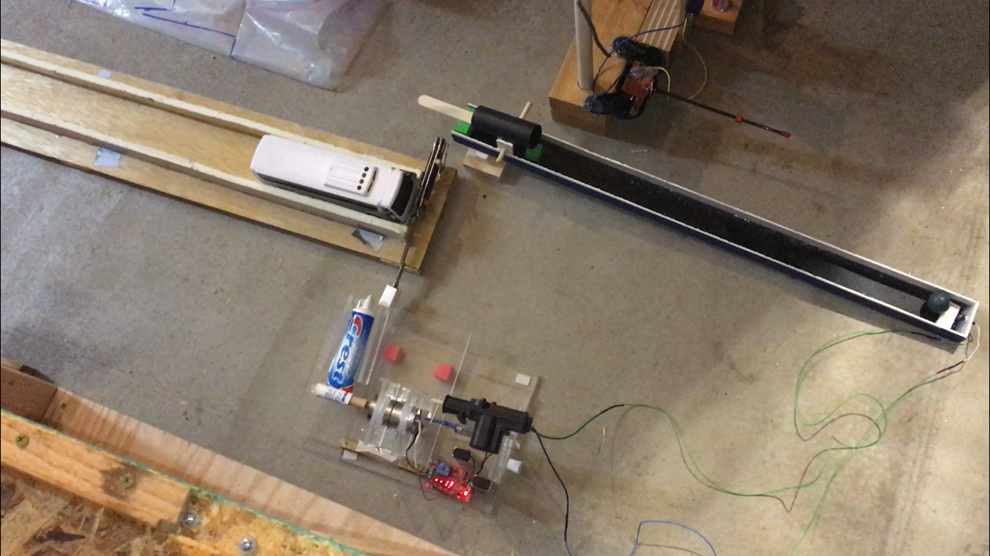
Figure 41: Final Steps Assembly

Arduino Assembly

Steps 1-3 (button-light-servo)
Set up the breadboard as shown in figures 42, 43, and 44. You will need the red button, wires, two 220 ohm resistors, the LED strip, an uno board, and the servo with the red 3D printed assembly. The breadboard is positioned on the front panel of the wooden supports in the most top and most left corner. The uno is settled on top of the wooden support in the back with the wires sent through the hole above the breadboard.
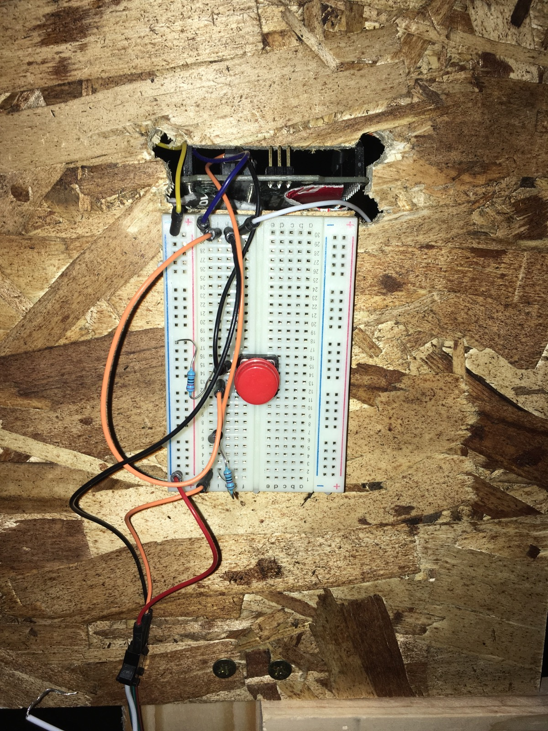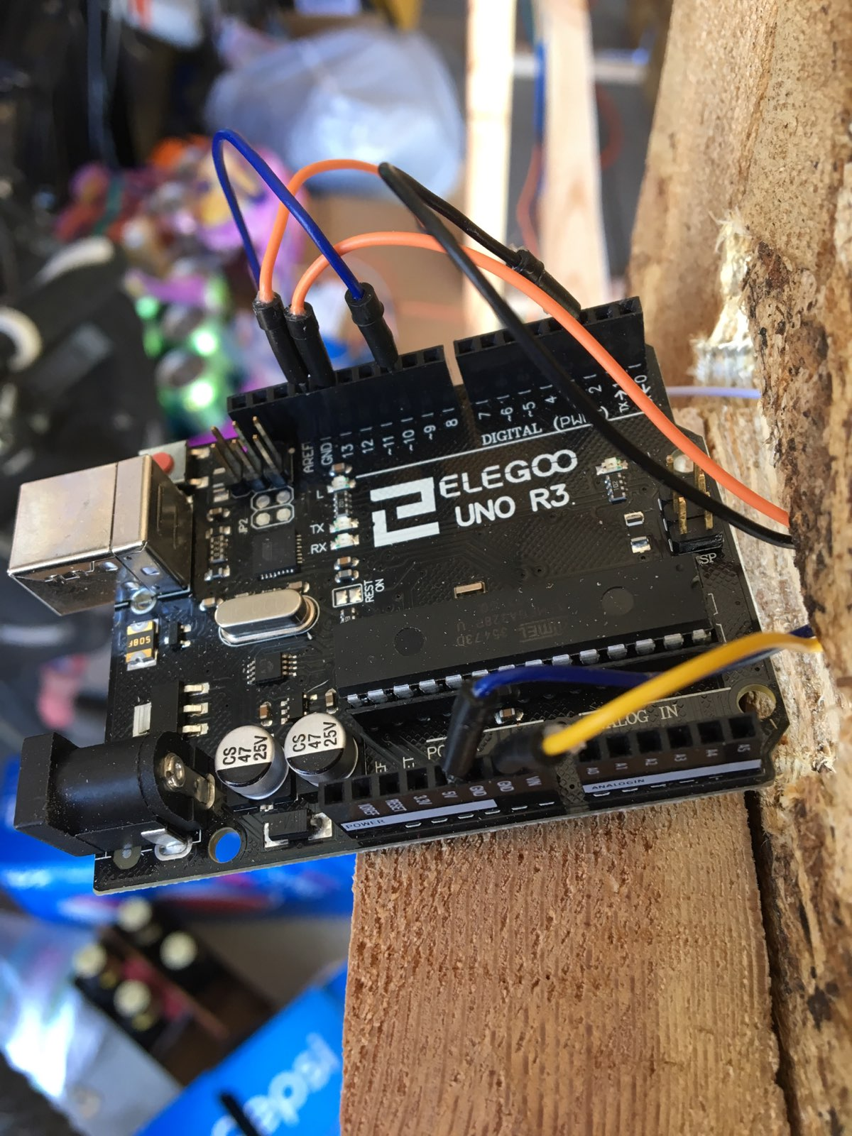
Figure 42: Breadboard with Button Figure 43: Arduino for LED, Mail Arm
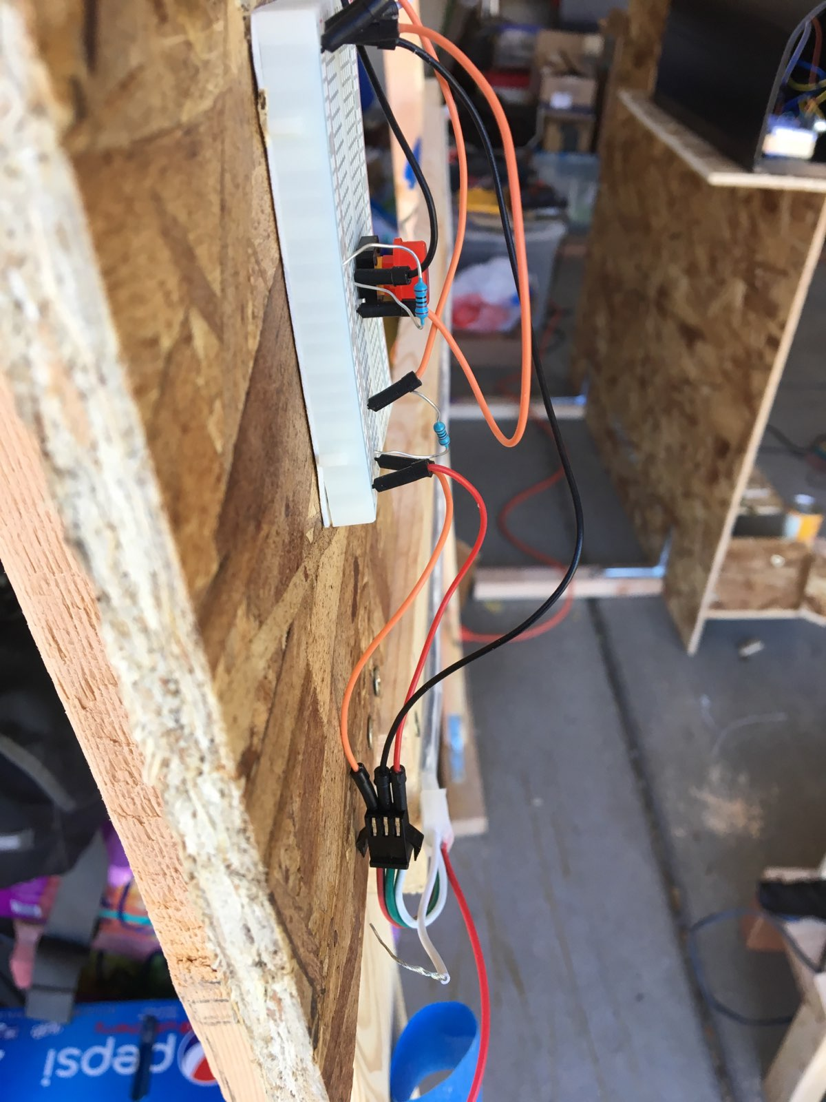
Figure 44: Wire Connections to LED strip

Starting with the button in the middle, the first upper left pring is connected to a black wire that moves up the breadboard and plugs into digital pin 2 on the uno board. At the starting port black wire, next to the button, a 220 OHM resistor is plugged in next to it with the end moving to the negative section which gets grounded later on. Next is the orange wire on the bottom left prong of of the button. This moves to port i30 on the breadboard. Then coming from the digital pin 13 is an orange wire that connect to the top of the second resistor. At the end of the resistor in slot i2 in the bread board in j2 is another orange wire that connect to the red wire of the LED strip. The red grounded wire next to it connects to the white wire in the LED strip. The green wire in the LEd strip is connected to a black wire that travels the h30 section in the breadboard. The yellow wire in the last negative slot is connected to ground on the uno board. The blue wire connected in j30 is slotted into the 5V pin in the uno board. In g30 is a white wire that connects to the red wire on the servo motor. The blue wire in pin 10 is connected to the orange wire on the servo motor and lastly the orange wire i the second ground pin connects to the grey wire on the servo motor.

Step 4 (inside mailbox)
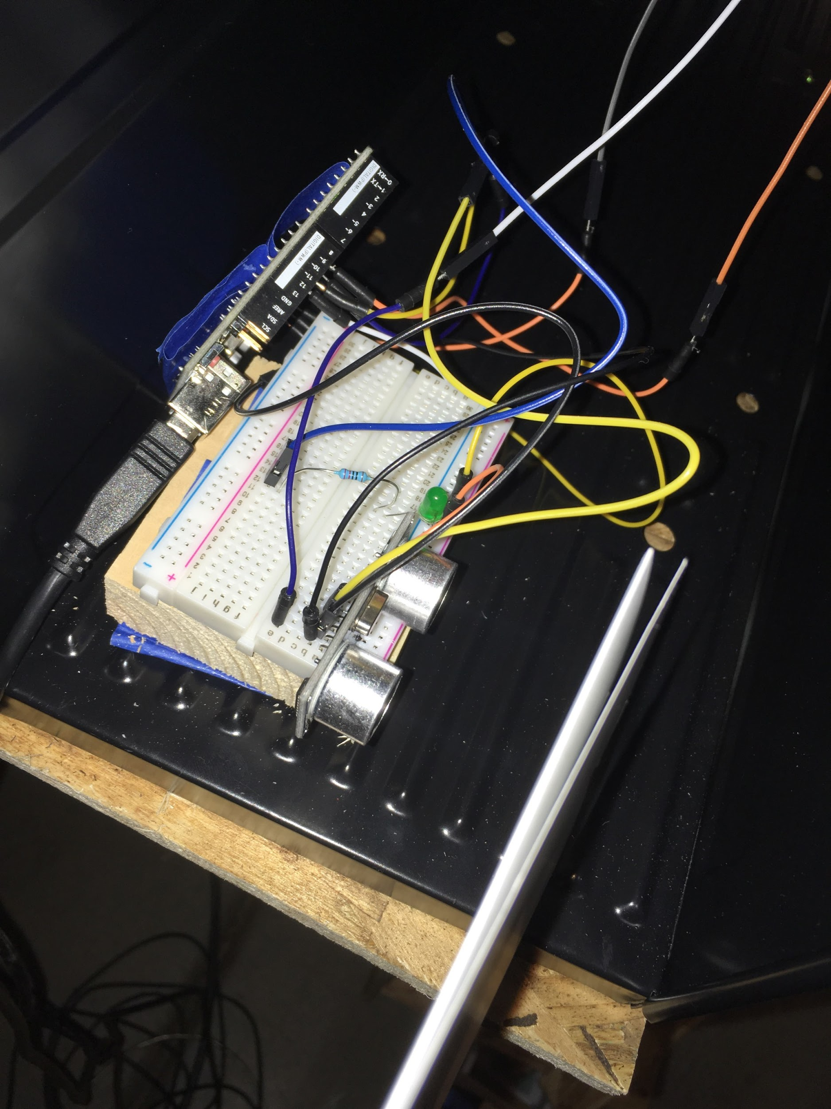
Figure 45: Arduino Setup Inside Mailbox

The parts needed are a mini breadboard, an led, a mini servo, an led, one 220 ohm resistor, an uno arduino board, an ultrasonic sensor and lastly several male-male and male-female wires. First, secure the breadboard to the inside of the mailbox and attach the ultrasonic sensor to the edge of the bread board, closest to what is going to give the input. Then connect the black wire to the input on the back of the sensor that reads “ground”.This wire then connects to the pin on the uno board labeled as . This is how the parts are going to get power. Then wire next to it, which is also black into the pin that reads “echo” on the back of the ultrasonic sensor. This then connects to the white white female male wire which then connects to digital pin 12. Next take the yellow wire and attach it pin on the ultrasonic sensor that reads “trigger”. This wire will then slot into digital pin 11. Next, take the orange wire then attach that to the pin on the uno board that reads “vcc”. This wire then attaches to the positive side of the LED. Next to that is a yellow wire that connects to the red wire on the servo motor. The LED is then connected to a 220 ohm resistor which then connects to a blue wire that leads to 10. Behind the ground pin is a blue wire that then connects to ground (the grey wire) on the servo motor. Lastly on pin 9 there is an orange wire that leads into the orange wire on the servo motor.

Step 5 (outside mailbox)
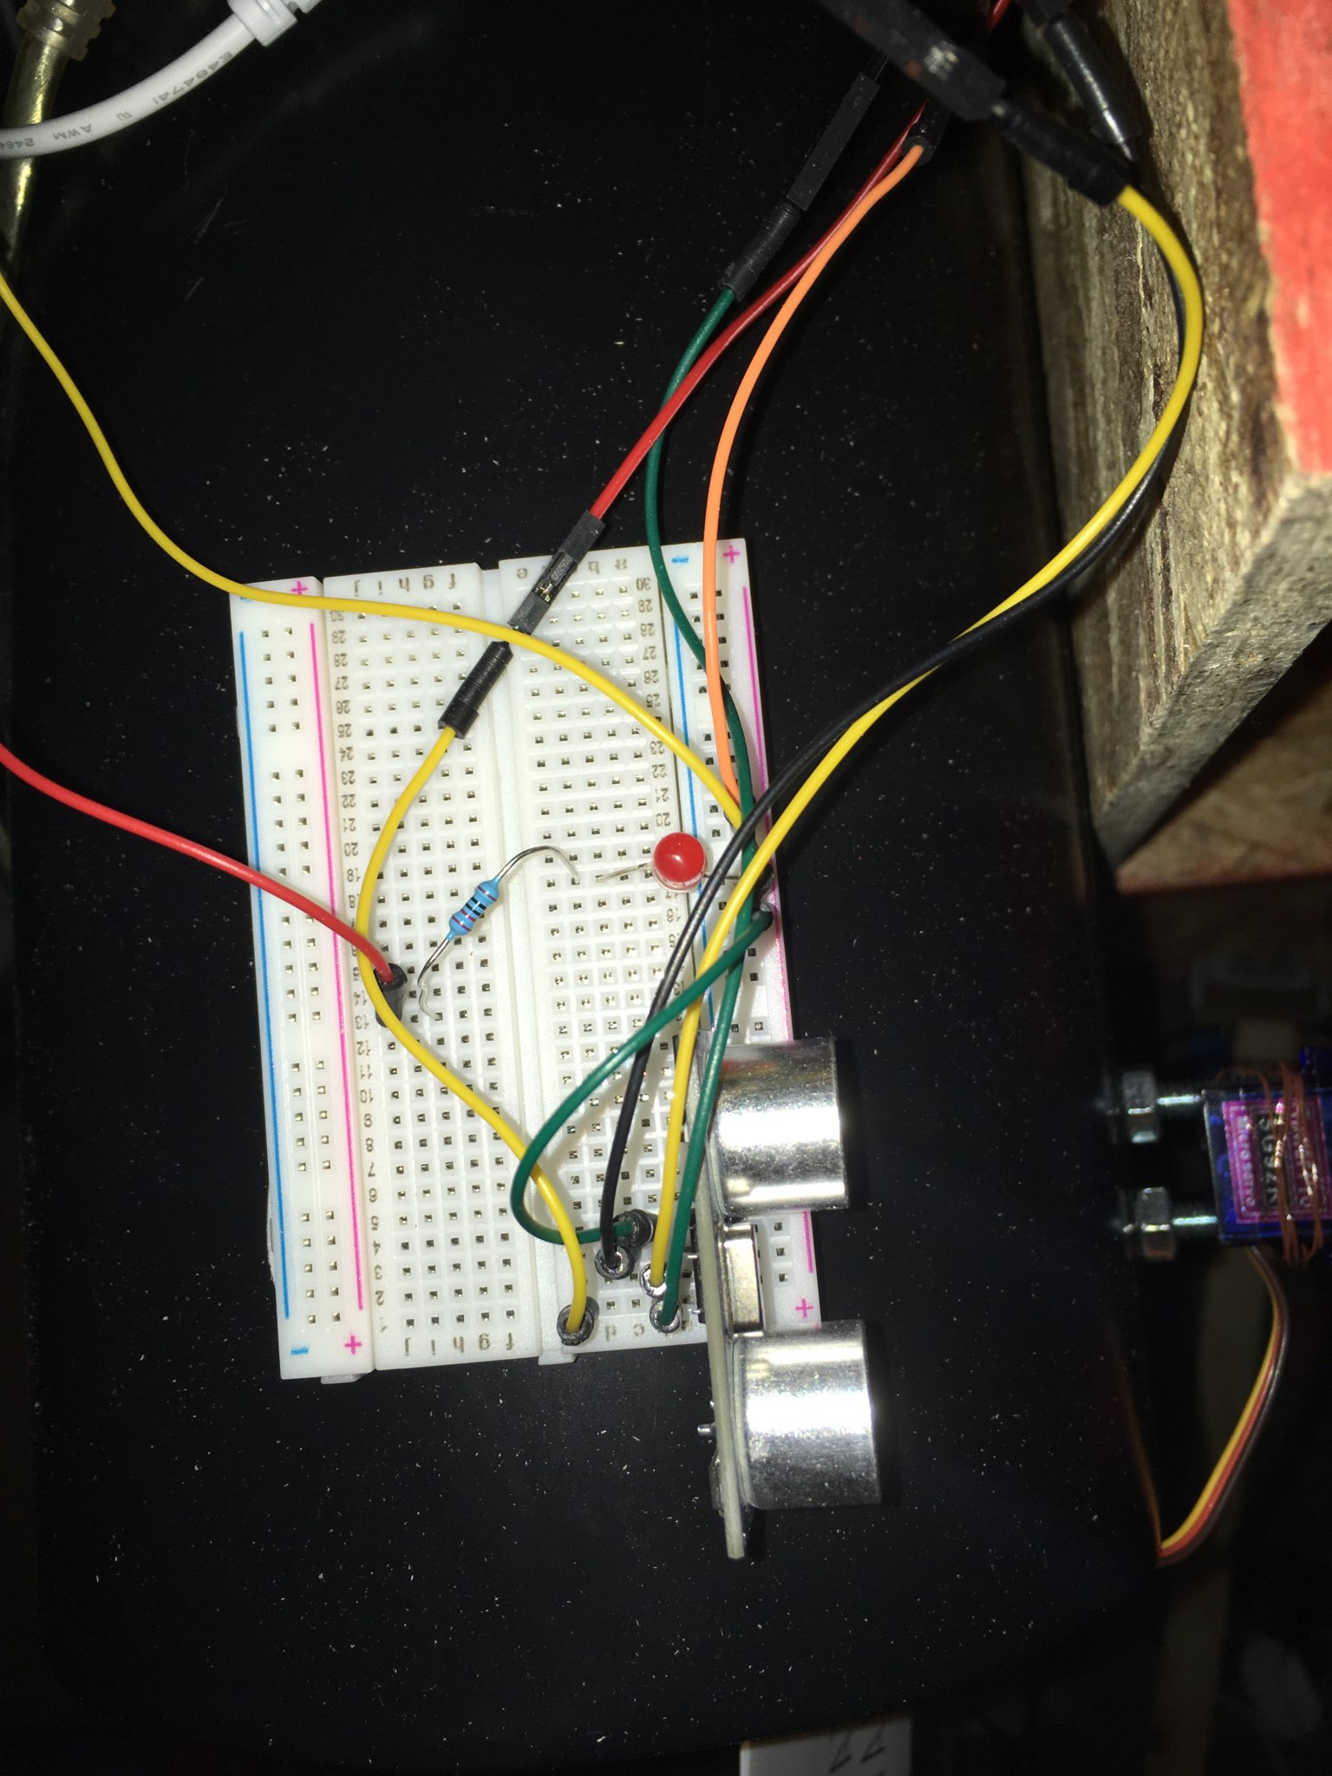
Figure 46: Arduino Setup Outside Mailbox

Set up the breadboard as shown in Figure 46. This is set up almost exactly the same way as Step 4. The only changes being the colour of the wires. The vcc wire is now green, the trigger wire is now black, the echo wire is now yellow, and the ground wire is now green as well.

Steps 12-13 (sensor-wiffle servo)
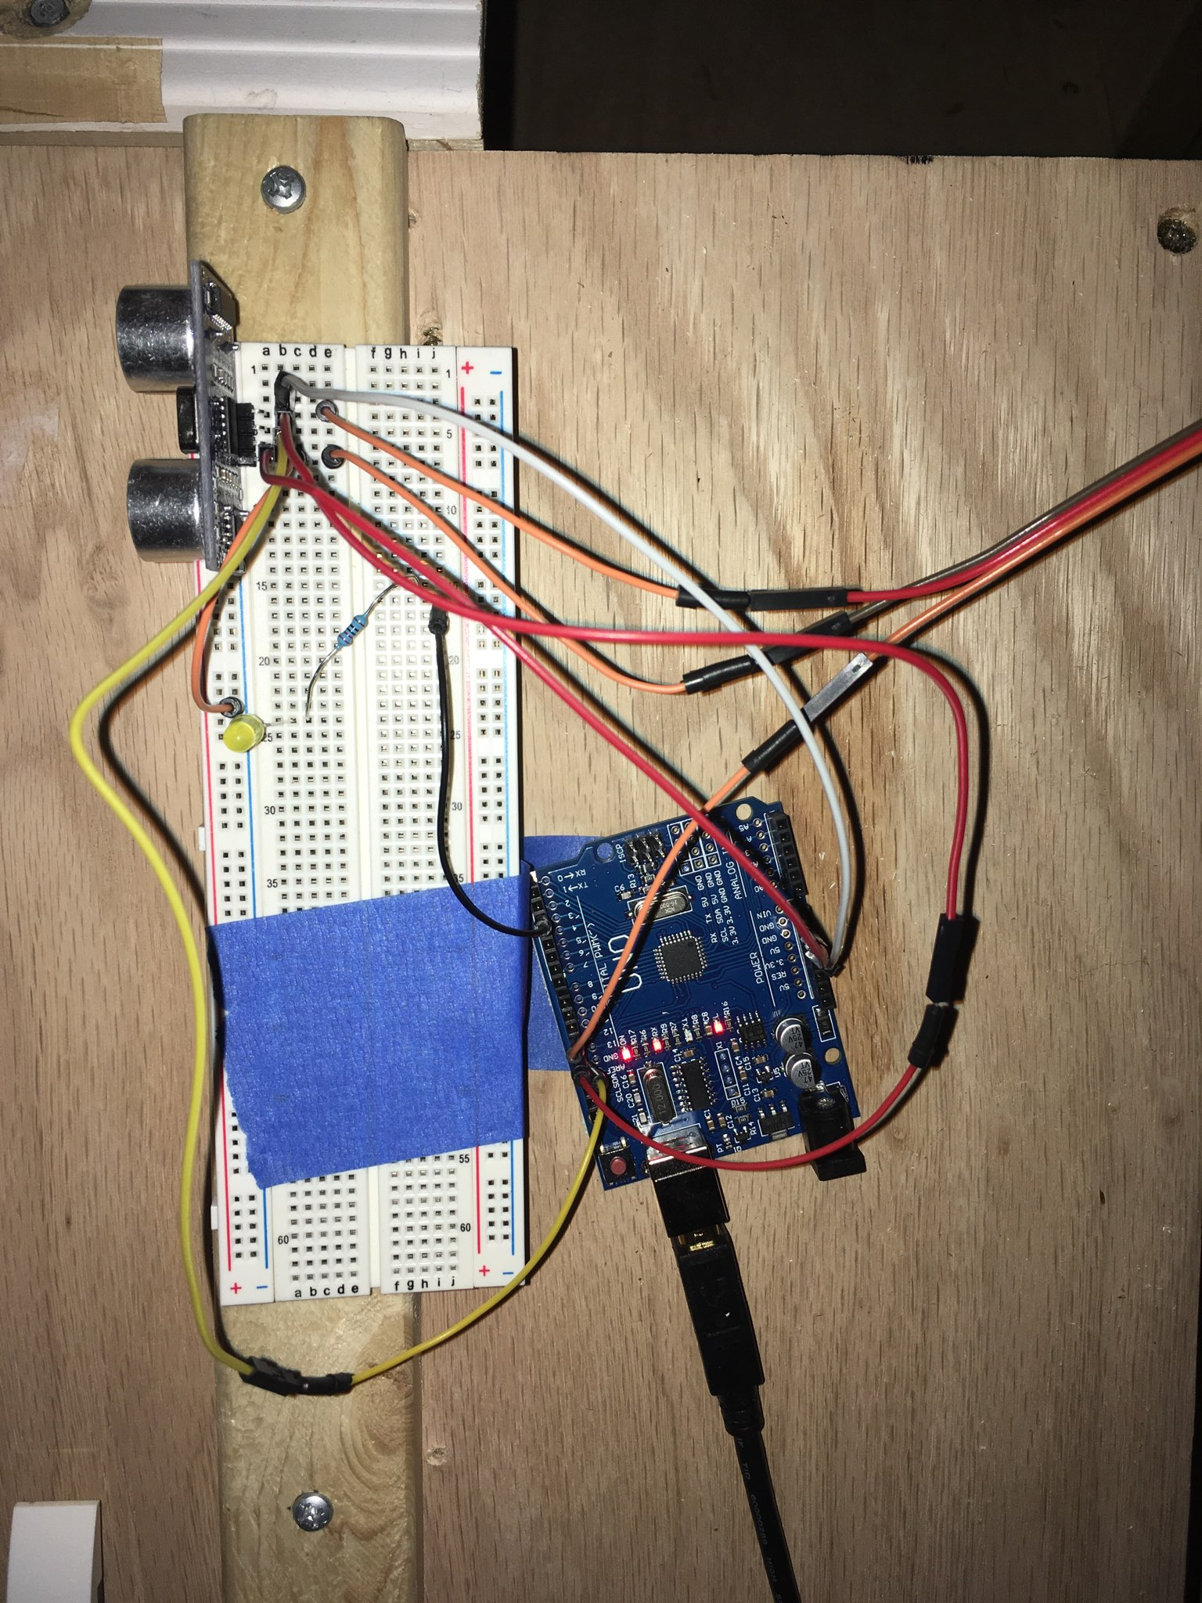
Figure 47: Arduino Setup for Car Ramp

Set up the bread board and uno board with their components as shown in figure 47. This is set up in almost exactly the same way as Steps 4 and 5. The first red wire shown on the bottom of the sensor closest to the viewer, connects into “vcc” which gets plugged into the 5v on the uno board. Directly behind it, the first orange wire gets plugged into the positve side of the LED and the negative side of the resistor gets connected to a 220 OHM resistor. The black wire connected to the 220 OHM resistor gets slotted into digital pin 3 on the uno board. Back to the second orange wire in the vcc line, it gets plugged into the grey wire of the servo motor. The next pin upwards is the trigger pin. A yellow wire is connected to it, which then gets connected to ground on the uno board.Next is the red wired located behind the echo pin on the uno board. This wire continues on to plug into digital pin 13. Behind that is another orange wire that connects into the red wire of the servo motor. The next pin is the ground pin connected to a white wire that plugs into 3.3V on the arduino board.

Machine Operation
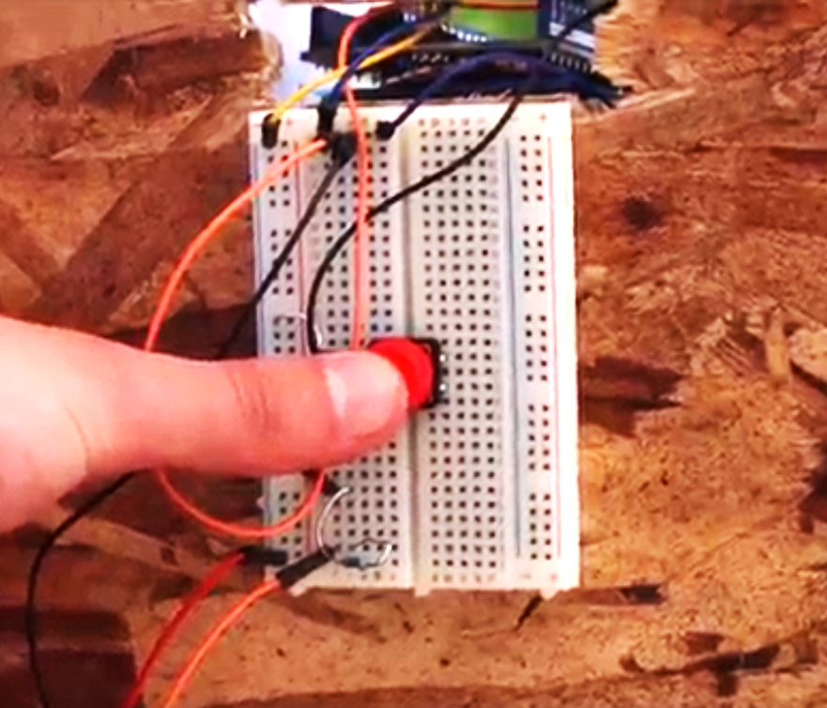

Starting the Machine

Step 1: Press the red button.

If everything has been assembled correctly then this will be the only step required to begin the chain reactions. You will know that everything is correct if the steps go as follows:

- The button starts a string of lights that runs from left to right.
- At the right most light flashing on and off; the continuous servo extends the mail into the mailbox.
- The green light inside of the mailbox lights up upon the mail entering.
- Once the mail arm lifts up; the red light on top of the mailbox lights up.
- The servo attached to the main component rotates 90 degrees and back.
- The jar has been hit straight by the servo attachment and knocks over the wooden plank at the end of the shelf.
- The drawer is pulled easily and without friction because the plank has fallen over the rod attached to the main component.
- Drawer movement has released the rock, which falls into the tube and onto the open bellow.
- The bellow has closed and blown air onto the spinner.
- The spinner has spun with enough force to knock the ball bearing into the lever arm attachment.
- A blue light turns on where the opposite end of the lever has pressed.
- The hair dryer turns on.
- The balloon on top of the toy car expands, and the car is sent up the ramp.
- The yellow light at the top of the ramp turns on.
- The servo motor with the wiffle bat attachment has rotated 90 degrees and back.
- The ball bearing is hit off its’ stand.
- The ball bearing runs down the clear tube and into the open end of the pulley.
- The other end of the pulley is quickly drawn upwards and triggers the switch.
- Immediately after the switch turns on the car platform is drawn back and begins to tilt.
- The car falls off and lands on the punching arm platform.
- The punching arm is pushed up and makes contact with the bottom of the ball ramp.
- The ball rolls down the first ramp and lands in the cup.
- The pin is pulled from in front of the first newton’s cradle ball.
- The axle of the centripetal force component begins to spin.
- The balls at the end of the extended arms on the axle rise up in vertical position, which pulls the pin in front of the quarter.
- The quarter rolls down its’ ramp and into the funnel. It should circle around the funnel several times before falling into the central component.
- Water begins to spout once the quarter hits the bottom of the coin funnel component and the water wheel begins to spin in one direction.
- The left hand nut that is attached to the water wheel is slowly drawn back and released.
- The RC car rapidly hits the end of its’ runway and triggers the switchblade toothbrush.
- After the switchblade is triggered, a ball runs down its’ runway until it hits the end.
- The toothpaste tube drops and is rolled until the toothpaste is squeezed out.

Troubleshooting
Here are some suggestions in case the machine does not run as intended:

- If the button does not trigger the lights and/or the servo; make sure all of the wiring is correct as described in the assembly manual. Check to see if the uno board is connected to power.
- If the green light inside the mailbox does not turn on; ensure that the mail is entering the mailbox within range of the proximity sensor. Check to see if the uno board is connected to power.
- If the red light on top of the mailbox does not turn on; set the mail arm parallel to the ground and with the end pointing right. The weight of this component may cause drooping and the 90 degree motion will still be out of range of the proximity sensor above the mailbox. Check to see if the uno board is connected to power.
- If the servo on the main component does not function as described; check if the uno board is connected to both the main power hub as well as the 9V power source. If the motor is not getting enough power it will malfunction. Ensure that the servo attachment is situated at about a 45 degree angle from pointing down.
- If the jar is not rolling straight; ensure that the servo attachment is positioned correctly. Face the jar perpendicular to the shelf directly in the center. Make sure the jar is within range of the servo attachment.
- If the plank does not fall straight over the rod then the placement of either the jar or the plank were off. The plank position is supposed to be at the center of the shelf’s width positioned at the rightmost end of the shelf’s length. The width of the plank should be aligned with the width of the shelf, meaning the width of the plank is getting hit by the jar. The plank should be positioned vertically and not on its’ side.
- If the drawer does not release; ensure that the drawer components on both the main component and the support attachment are the right distance away. This could mean adjusting the support until the drawer glides smoothly on the rails without coming off them.
- If the rock does not drop; make sure the position of the rock was correct. It should be placed on the very corner of the drawer nearest to the main component. The rock should be balanced on the edge so that it is easy to disturb its’ position.
- If the bellow is not open then adjust the spring that holds the arms apart. The spring may need to be reglued to the arms if it becomes disconnected.
- If the spinner does not knock the ball into the lever arm; fix the spinner’s position. The flag must be normal to the flow of air from the bellow and when spun the innermost part of the flag is what hits the ball.
- If the blue light under the hair dryer-cart step does not light up upon the lever being triggered; try and put more weight on the ball catchment end of the lever and if the light does not turn on then check the position of the rod on the hair dryer end of the lever. The rod must press the green button firmly, if it does not press the button directly then move the arm laterally on its’ support rod or use a zip tie to adjust how close the button end lies to the hair dryer-cart supports. Check the arduino board to see if the white adapter is plugged in. Check that all the wires are in the correct location and if they are then try and push them into their pins to be more secure.
- If the blue light turns on but the hair dryer does not; check that the black wires are attached to the motor shield and the the black adapter is plugged in. If it still does not work then press the reset button on the black adapter.
- If the balloon does not inflate; check if it is pinched anywhere or if there is a hole in the balloon.
- To replace a broken balloon; lift the lego piece that holds down the balloon, place the open end of a fresh balloon on the cart, and replace the lego piece to secure.
- If the yellow light does not turn on; press the proximity sensor into place. If this sensor droops then it will pick up noise from the railings. Check that the uno board is plugged in.
- If the wiffle bat servo does not move; ensure all the wires are set up correctly. If the gears are not moving and the arduino components are all set up correctly and connected to power then get the gears going by rotating the wiffle bat and forcing the gears to move by hand. If the gears are disconnected then replace the servo motor and use the wiffle bat attachment on the new motor.
- If the ball does not roll into the pulley attachment; make sure the opening of the tube aligns with the opening of the pulley attachment and there is little space between the two.
- If the opposite end of the pulley does not trigger the switch; ensure that the starting position of this end of the pulley is within the guide rails, not below or outside.
- If the car ramp does not move; make sure the batteries are connected and turned on.
- If the punching arm is not triggered; align the exit of the car ramp above and next to the platform the car is supposed to fall onto. Make sure the batteries are connected and turned on.
- If the ball does not roll down the ramp once hit; restart the step with the ramp being level and parallel with the ground. If the ramp is not level to start then the ball will not roll once tipped.
- If the newton’s cradle step does not trigger the centripetal force step; check that the batteries are connected and turned on.
- If the balls on the centripetal force arms do not pull out the pin on the quarter; adjust the position of the centripetal force step. Ensure the pin has the bent end facing down.
- If the coin does not release properly into the funnel; adjust the position of the step.
- If the coin funnel does not start the water wheel; check that all the electronic components are attached to batteries and turned on.
- If the water wheel does not spin in one direction; then either add or remove water to the basin.
- If the nut is not pulled by the water wheel; make sure the water wheel is functioning correctly first. Position the nut so that it will be released in only a few turns, otherwise the winding up of the string may take too long.
- If the RC car is not triggered by the dual pendulum step; make sure both the dual pendulum step and the RC car are turned on and has battery power.
- If the ball does not trigger the toothpaste tube falling then place another ball by the button before having the released ball run down the runway. The added weight helps trigger the button.
- If the toothpaste does not release; make sure all the components are attached correctly, are turned on, and connected to battery.
- If the toothpaste is not squeezed out; make sure the end of the toothpaste tube is secured around the clothespin and wrapped around it until the clothes pin is at the end of where the tube is filled to. If it is a new tube then the toothpaste will not come out until the end has been wrapped a couple times.

How to Reset
- Make sure the rolling jar is in its’ original position.
- Replace the plank to its’ original position.
- Replace the rock on the drawer.
- Return the spinner ball to its’ place and bring the spinner to its’ original position.
- Return the wiffle ball to its’ stand.
- Return the pulley to its’ original position.
- Return the large ball and it’s ramp to their original position.
- Replace the pin behind the first newton’s cradle ball.
- Replace the quarter and pin on the ramp.
- Reattach the nut to the magnet connected to the water wheel axle.
- Return the RC car to its’ original position.
- Return the switchblade to its’ original position.
- Return the final ball to its’ original place.
- Reset the final toothpaste assembly to its’ original position.

